NSVS Plug-In for VStar

Install the NSVS (Northern Sky Variability Survey) plug-in by going to the tool menu and selecting Plug-in Manager. AAVSO login is required. Scroll to and select NSVS file reader and click on install. After installation, restart VStar.
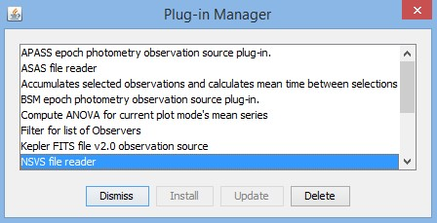
To obtain an NSVS file, go to the NSVS database. In my example, I am going to obtain my data from SkyDot (http://skydot.lanl.gov/). Select Northern Sky Variability Survey from this page.
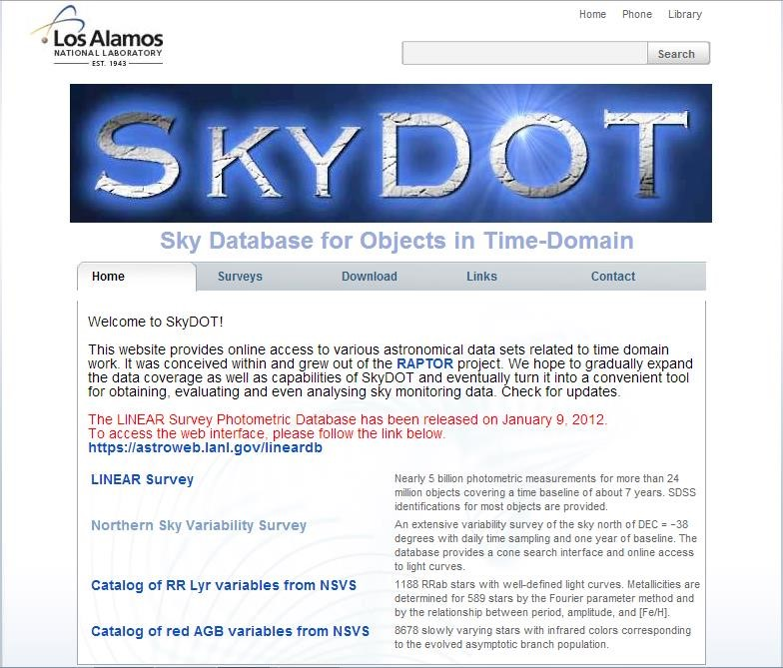
Perform a search around your coordinates of interest.
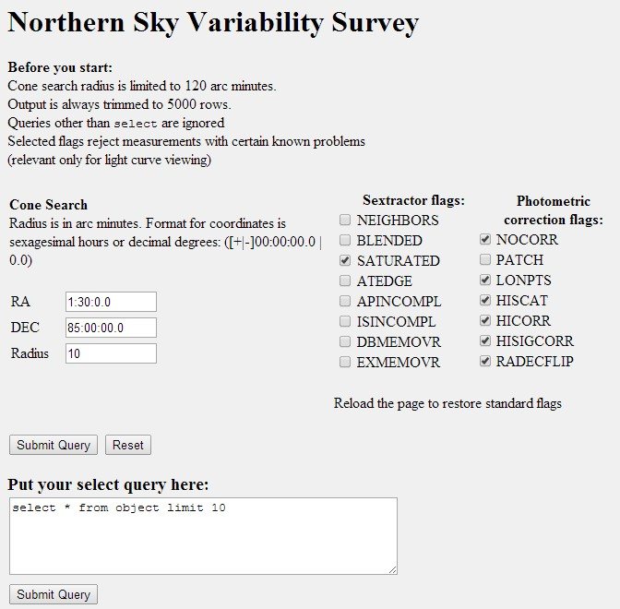
A list of objects from the NSVS database around your coordinates at the radius you specified will appear. Click on the object ID of interest. I will select the object in row 1 for my example. So I will click on Obj ID 61936.
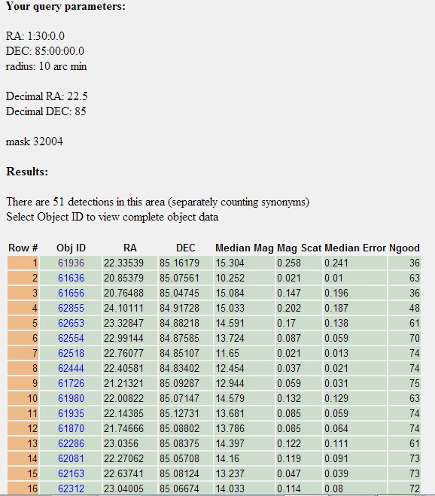
Select the table of data on the right side of the page and paste it into notepad or a similar text editor. Save the file as a .txt file.
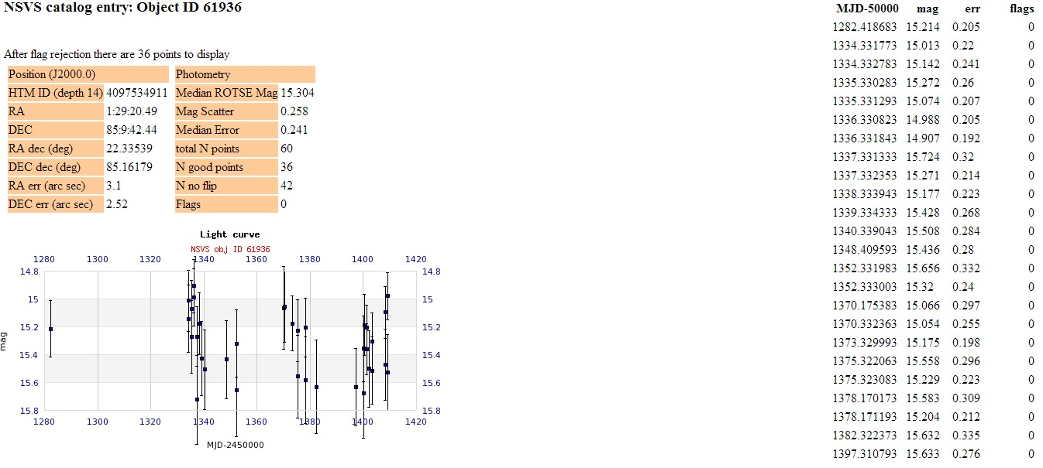
In VStar, in the file menu select “New star from NSVS file”.

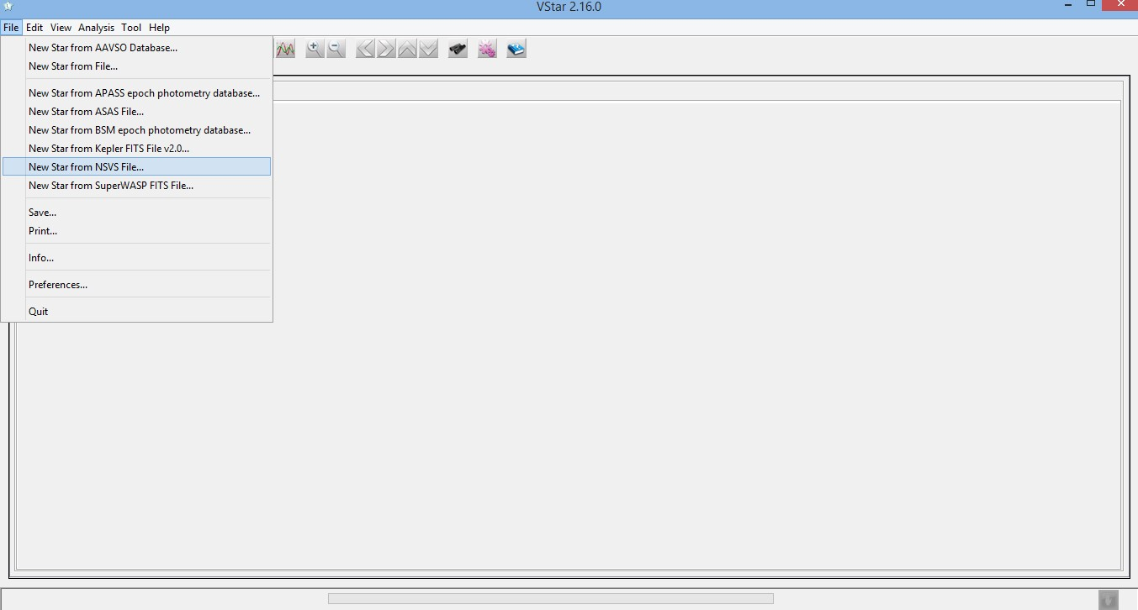
Browse to your saved NSVS file and select it. The raw NSVS data for that object is now available in VStar to be analyzed.

